**CUMBRIA WORKFORCE INTELLIGENCE**

**Contents**

|  |  |
| --- | --- |
|  | Page |
|  |  |
| 1. Cumbria Health Profile | 2 |
| 1. NHS Workforce | 4 |
| 1. Social Care workforce | 8 |
| 1. Primary Care Workforce | 11 |
| 1. Education | 14 |
|  |  |

1. **Cumbria Health Profile**

**Source:** Public Health England: Local Health Profile

**Further details at:** HealthProfile2015Cumbria16.pdf

**Health in summary**

The health of people in Cumbria is varied compared with the England average. Deprivation is lower than average, however about 14.7% (12,000) children live in poverty. Life expectancy for both men and women is lower than the England average.

**Life Expectancy**

Life expectancy is 9.5 years lower for men and 7.3 years lower for women in the most deprived areas of Cumbria than in the least deprived areas.

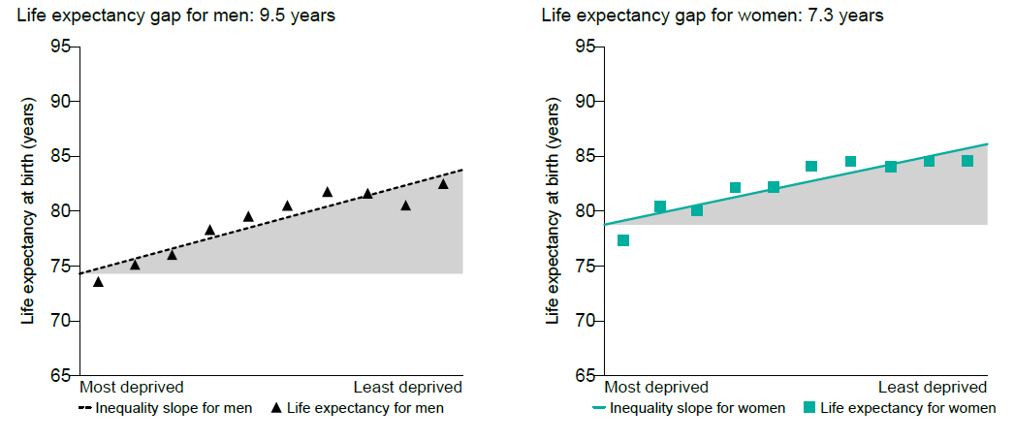

**Child Health**

In Year 6, 19.3% (869) of children are classified as obese.

The rate of alcohol-specific hospital stays among those under 18 was 68.0*, worse than the average for England. This represents 65 stays per year.

Levels of breastfeeding and smoking at time of delivery are worse than the England average.

Levels of teenage pregnancy are better than the England average.

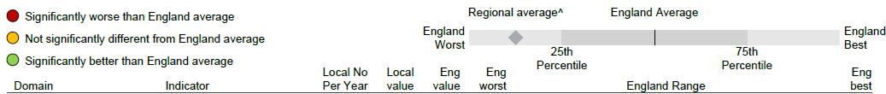

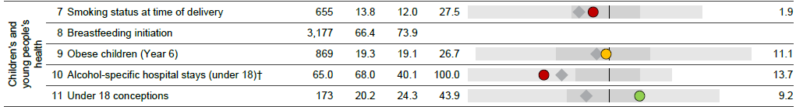

**Adult health**

In 2012, 23.9% of adults are classified as obese.

The rate of alcohol related harm hospital stays was 742*, worse than the average for England. This represents 3,767 stays per year.

The rate of self-harm hospital stays was 266.0*, worse than the average for England. This represents 1,250 stays per year.

The rate of smoking related deaths was 297*. This represents 973 deaths per year.

Estimated levels of adult excess weight are worse than the England average.

The rate of people killed and seriously injured on roads is worse than average.

Rates of sexually transmitted infections and TB are better than average.

Rates of statutory homelessness, violent crime, long term unemployment and drug misuse are better than average.



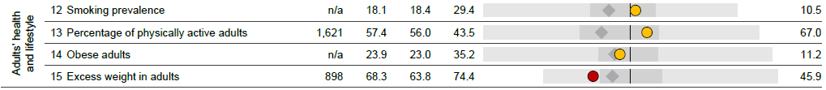

**Local priorities**

Priorities in Cumbria include reducing inequalities, ensuring children get the best start in life, improving mental health and wellbeing, and supporting an ageing population.

1. **NHS Workforce**

**Source:** ESR Data Warehouse Sep-15

**Overview**

In Cumbria there is a staff headcount of 13,463 which in FTEs represents 11,608. The workforce in this area is relatively young with only 5% of staff working towards retirement age (over 60). The majority of the workforce, nearly 60%, is aged between 40 and 60. Bands 3 to 6 represent 75% of the workforce in Cumbria which drives the average cost of employee as £27k per year.

**Further details at:** [**http://www.hscic.gov.uk/searchcatalogue?productid=19283&returnid=1907**](http://www.hscic.gov.uk/searchcatalogue?productid=19283&returnid=1907)

Overview of Cumbria, North Cumbria and NWAS Workforce from the ESR Data Warehouse Sep-15

Table 1 shows the overall workforce by headcount and FTE as at September 2015 which is the most up to date position available from the ESR Data Warehouse.

Table 2 further breaks down the headcount by staff group.

*Table 1*



*Table 2*



33% of the workforce in Cumbria is made up of Nursing staff. NWAS data covers all of the NW and therefore can’t be broken down to Cumbria .

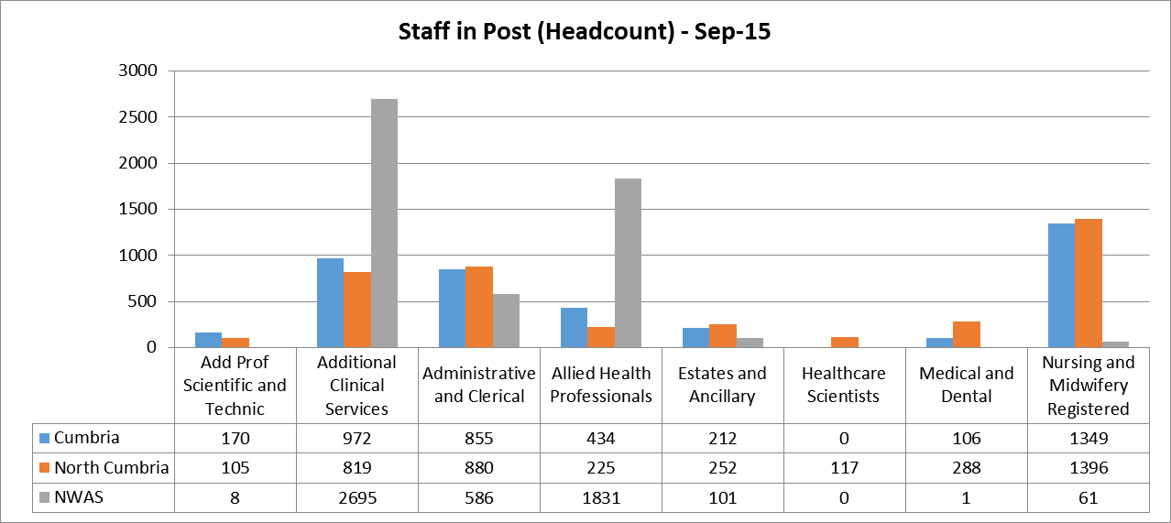

Bands 5 make up the largest proportion of staff with 31%. Non AfC accounts for 8% of staff which is 419 out of 8180 staff across the area. This figure does not include NWAS as this cannot be broken down to show the Cumbria split.

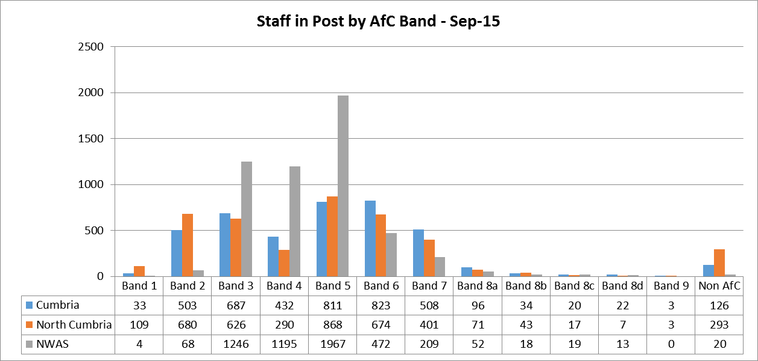

Table 3 shows the staff in post headcount breakdown by percentage.

*Table 3*



The majority of staff are aged between 40 and 60 years (58%). 37% of staff are aged between 25 and 39. 5% of the workforce are over 60.

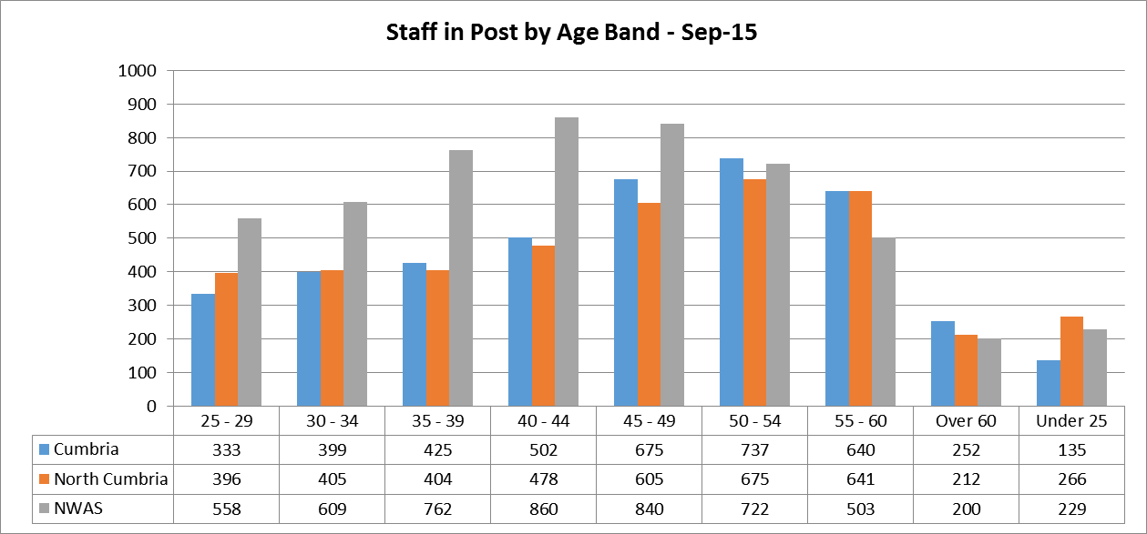

Table 4 calculates the average cost of each employee within Cumbria and NWAS based on the overall headcount for each Trust. As represented previous, Band 5 makes up the largest proportion of staff which reflects the average cost of £27,101.

*Table 4*



1. **Social Care Workforce**

**Source:** Skills for Care publication, NMDS-SC

**Further Details:** **Cumbria.pdf**

**Overview**

In Cumbria there are an estimated 19,500 jobs in adult social care. These are split between the statutory sector (3,100), the independent sector (13,600) and direct payment recipients (2,800).

Cumbria has an estimated population of 113,800 people over the age of 65. This number is predicted to increase to 126,100 people by 2020.

The Cumbria area contains 313 CQC registered services, as at July 2015, which is 8% of all those in the North West region (3,686). Of these, 184 are care homes with and without nursing.

**Staffing overview**

As at July 2015, the NMDS-SC holds information on 9,600 staff working in adult social care in Cumbria. Across the whole sector in Cumbria, Skills for Care estimates that there are 15,000 direct care workers, 1,650 managerial and supervisory workers, 750 professionals and 2,100 jobs in other non-care providing roles in social care.

Cumbria has an average full time equivalent job ratio of 0.76, meaning that on average 100 jobs equates to around 76 full time jobs. These estimates have been created based on 37 hours per week being classed as ‘full -time’.

The average number of sickness days taken in Cumbria was 7 in the last year, which is equal to the regional average of 7 days per year. Sickness is a large cost to the sector, with an estimated workforce of 19,500 this would mean Cumbria lost 136,200 days sickness in the last year.

**Recruitment and retention**

The NMDS-SC shows that Cumbria has an average staff turnover rate of 17.9%, as at July 2015. This is lower than the turnover rate for North West which is 22.4%. The turnover rate varies depending on job group. Direct care staff have the highest turnover rate (20.0%), followed by regulated professional staff (14.8%) and managerial staff (7.7%).

Additionally, as at July 2015, Cumbria has a vacancy rate of rate of 2.1%.

Given an estimated 15,000 direct care jobs in Cumbria and a turnover rate of 20.0% this equates to around 3,000 positions being made vacant in the last 12 months. Managerial and supervisory roles had a turnover rate of 7.7% and an estimated 1,650 jobs, this equates to around 125 positions being made vacant. There are an estimated 750 regulated professional roles, and a turnover rate of 14.8%, this equates to around 100 positions being made vacant in the last 12 months.

**Demographics**

The majority of the workforce in Cumbria is aged between 45 to 54, with an average age of 43. Those aged 24 and under represent 12% of the workforce and those aged over 65 represent 3.5%. With an estimated workforce of 19,500, 2,200 jobs could be lost to retirement in the next 5 years.

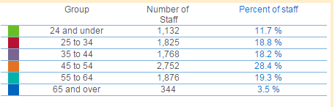

The majority of the workforce are female (87%).

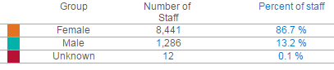

The ethnicity of workers is mainly white (92%), with the remainder being of black and other minority ethnic groups (3%). Across the North West as a whole, 92% are of white ethnicity and 8% are of black and other minority ethnic groups.

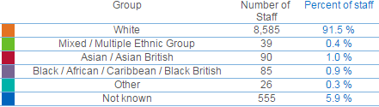

**Pay**

The average annual and hourly pay by job group for your area, and how these compare with the regional and national averages, is shown Table 1 below.

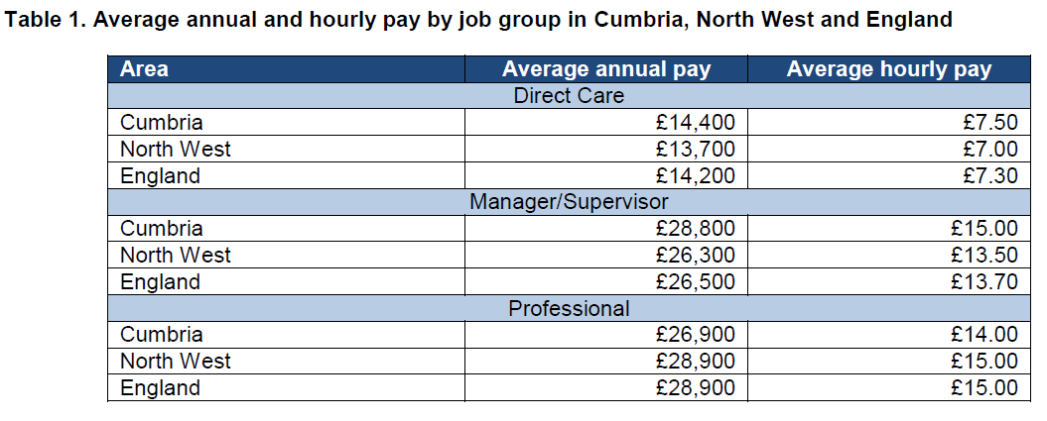

**Qualifications**

The NMDS-SC shows that 56% of the workforce in Cumbria holds a relevant qualification in adult social care. This is lower than the average for the North West wherein 66% hold a qualification. Around 47% of direct care workers hold a level 2 or above social care qualification in Cumbria.

1. **Primary Care Workforce**

**Source:** Health and Social Care Information Centre (HSCIC)

[**http://www.hscic.gov.uk/catalogue/PUB16934**](http://www.hscic.gov.uk/catalogue/PUB16934)

**See “detailed tables.xls” file and “Anonymised Practice level and GP level Census data.zip” file**

**Overview**

GP data has been sourced from the Health and Social Care Information Centre (HSCIC) as at September 2014. This is the primary source at present, however HENW are in the process of launching a data collection tool that will link to the Primary Care Tool, and this will be available between Jan-Mar16.The HSCIC data is available at both GP Level and Practice level.

GP Level - this data is mapped to a CCG and therefore not available at practice level. Data can be extracted by the following:

* Staff group
* Job role
* Age (in years)
* Gender
* FTE

Practice Level - this data is mapped to an individual practice. Data can be extracted by the following:

* Number of patients by gender and age band
* Aggregated GP FTE by job role, gender and age band

Within the analysis file the HSCIC publish, varying information is provided at CCG level.  HENW use elements of this data in their CCG reports (e.g. GPs per head of population, benchmarking) and to triangulate data.

In addition to the job roles, age, gender and FTE information HENW collect on behalf of the national collection, in the HENW collection, the following fields are also reported on:

* Ethnicity – providing a view of how representative of the local population the workforce is
* Skill set – enabling HENW to determine skill gaps, how funding (e.g. CPD) is contributing to upskilling the workforce, and to develop education frameworks taking into account current workforce competencies (e.g. we are looking over the next few months at the support roles within General Practice and we will be using the existing data to inform us what this part of the workforce is currently doing, to then inform a framework for development.)

HENW also collect, as do the national collection; vacancy and absence data.

**Analysis**

The below has been extracted using the GP level data for Cumbria CCG.

There are approximately 424 GP practitioners across Cumbria which makes up 7% of the total North West GPs (5,962). The gender split is approximately 50:50 with 211 male versus 213 female.

Over 50% of the workforce is aged 45 and over

Of the total practitioners, an overall 16% have qualified outside the UK. 20% of these are from the EEA, and the rest of these are outside the EEA

Admin and Clerical staff account for over 60% of the Practice staff workforce in Cumbria. In contrast Nursing staff only make up 17% of the practice staff workforce.

1. **Education Data**

HENW can report on Commissioning and Recruitment data by HEI within the North West region. Student numbers are reported on by programme and cohort. Commissions and Output both take place at the North West level in order to meet the demand of the regional and National Workforce Plans. There is currently no facility to track the student journey through to ESR; therefore the output cannot be measured at Area team and Trust level.