The Coaching Day (example)  07.00 the shift starts:  Coach meets with students and discuss the plan for the day.  Coach helps the student identify outcomes and set main objectives  11.00 Mid shift:  Focusing on the agreed learning outcomes, the coach works with and coaches the students  The coach agrees time out for the student to collect evidence and or resources that support learning  14.00 feedback during shift:  The coach meets with student and discuss progress  The coach reassess learning outcomes, make changes if appropriate  The coach discusses evidence gathered toward learning outcome  End of shift:  The coach reviews shift with student  The coach reviews which learning outcomes have been achieved  Gives feedback and feedforward  Completes the learning log  Acknowledges achievement,  and good practice | Coach -Student partnership  Coaches oversee and facilitate the learning of 2-3 students per shift, instead of performing tasks  Student assess, plan, implement, and evaluate care based on agreed daily learning goals  Coaches check the students learning needs and student plan for the shift (including priorities, delegation etc.)  The students provide holistic care for a group of patients including essential cares, multi-professional communication, discharge planning & handover of care.  Coaches provide verbal and written feedback on student’s achievements  Coaches reflect on their own learning and development (professional revalidation, PDP). |  | CLiP™  - East Lancashire Hospitals  - NHS Trust  - Working in partnership with UCLan  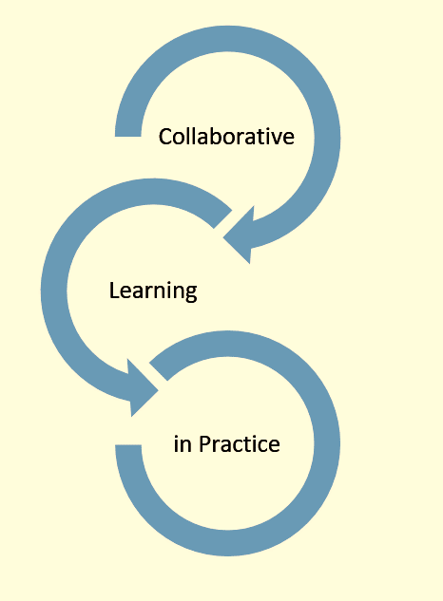

CLiP™  The Collaborative Learning in Practice (CLiP™) project was introduced to the UK in 2011 by University of East Anglia, School of Health Sciences. CLiP™ is based on the VU University Medical Centre Amsterdam (VUmc) ‘Real Life Learning Ward’ approach to supporting day-to-day learning in practice.  The approach is intensely student centred and based on coaching principles. During 2017- 2018 CLiP™ will be introduced to a range of different clinical learning environments across the UCLan placement circuit. The implementation of CLiP™ will be evaluated and you may be invited to contribute to this process. | Promoting High Quality  Patient Focused  Evidence Based Nursing Care  A coach:  - Encourages the student to identify their own learning needs and to work out how they might achieve them  - Creates a learning environment based on a culture of valuing, encouraging learning by doing, and positive reinforcement, enhanced by consistent and timely feedback.  - Encourages the student to provide solution focused patient care.  - Encourages the student to assume responsibility for the care they plan and deliver.  - Asks Questions and actively listens | Coaching questions may ask:  - What do you make of that?  - What do you think is best?  - Tell me more about that?  - What do you think this means?  - What is an example?  - What are the options?  - How else could you handle that?  - Can you talk me through why you think that’s the right thing to do?  - Can you say more about that?  - Can you explain why you did it that way?  And the coaching relationship will:  - Develop their coaching and facilitation skills.  - Develop their situational leadership skills.  - Update their knowledge.

