Student Public Health Conference, 15th June 2016
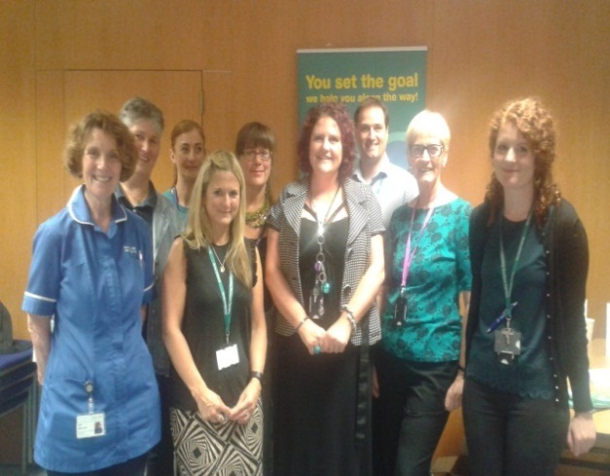
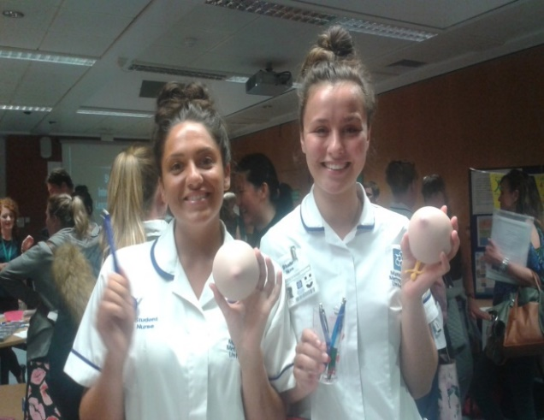

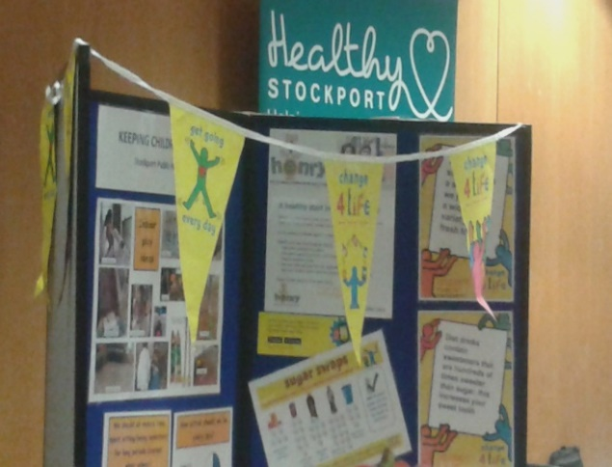
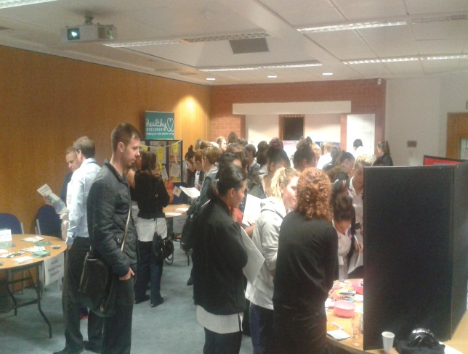

In Stockport, we have always been very keen to engage our healthcare students in public health initiatives and ensure they are well-informed about the importance of maintaining a ‘public health mindset’ at all times, as an integral part of their role.
As part of this agenda, a new initiative was recently planned in partnership with
Stockport MBC and Stockport NHS Foundation Trust, which involved delivering a
‘Public Health Conference’, for pre-registration health care students on placement in Stockport. The event was a great success, with 38 healthcare students attending and was excellently evaluated. The conference provided a wonderful opportunity for the students to learn more about public health services in Stockport and to explore their role in promoting health and sign-posting to services. In the afternoon, we held a ‘market-stall’ event, where a range of different public health staff attended and promoted their services. As part of the event, over 70 public health short ½ day or 1 day ‘spoke placements’, were promoted, which students were then able to book onto. This enabled the students to see public health ‘in action’ in Stockport and helped them to link theory to real-life practice.
During the event, the students also completed ‘pre’ and ‘post’ questionnaires, to assess the students’ confidence and knowledge, and these scores rose from an average of 43% to 68%, which was a great result.
The students also commented:-
- “The market-stall event was amazing! with really good opportunities”
- “I now have the knowledge to make a difference”
- “Fantastic, I loved it! Very informative”
- “It was very informative and I loved the opportunity to maintain this learning via the spoke placements”
- “I feel more confident about promoting good health and have a better understanding about people’s motivations or things that might inhibit their ability to change”

Since the event, one student has sent in a testimony, describing how she had put her new learning into practice and had helped a patient to consider life-style factors that were having a really significant, detrimental effect on her life. The next day, when the patient was leaving the ward, the patient called her over and said “thank you… everyone needs a ‘Sally* in their lives!”. Through the students input, the patient stated “I now feel I have a second chance to change things”. The student stated how overwhelmed she felt by the patient’s comments, which had reminded her exactly why she had chosen the nursing profession.
We would like to say a big thank you to everyone who was involved with this event – we couldn’t have achieved this without your support!
Sarah Booth, Eleanor Hill, Jan Sinclair.
*for confidentiality, this name has been changed

