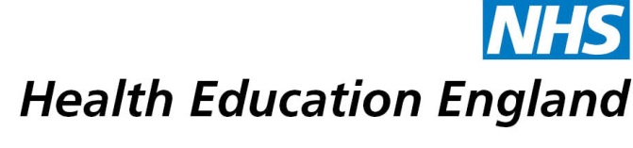
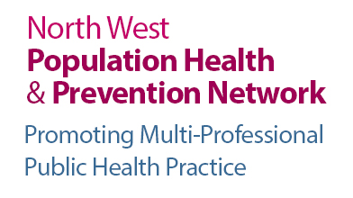

North West Population Health & Prevention Network

(Promoting multi-professional public health practice)

Who are we?
We are a new multi professional network for the health, care and voluntary sector workforce across the North West. We are funded by Health Education England working across the North West – improving the quality of care delivered to patients, promoting quality in education and training.

Purpose of the network
To support the health and wellbeing contribution of the health care workforce – particularly around self-care, prevention and making every contact count.
To help your role around health protection and health improvement, creating a culture of wellness rather than illness in healthcare work.

Who is the Network for?
If you work with patients or have caring responsibilities within your job role – then this network is for you. If you work in healthcare, social care or the voluntary care sector then this network is for you.

What do we do?
Provide you with access to a digital platform to share information, ideas, provide access to events, education and training opportunities.
Monthly e-bulletin to keep you updated on matters relating to your preventive healthcare role and health & wellbeing news, events and public health practice here in the North West.

Our Aim
To help you integrate health & wellbeing conversations into your everyday interactions with patients, clients and the public at every (appropriate) opportunity. Helping you to: - “Make Every Healthcare Contact Count”.

How to Join the Network
- Join online by completing the registration form on the NW PHPN digital platform at www.nwcpwd.nhs.uk/nwphpn-register and receive instant access to all the resources after verifying your email address
- Make sure you tick the registration box at the end of the registration form which will enable you to receive the NW PHPN monthly E bulletin
- Follow us on twitter @nwphpn
- For general enquiries email phpn.northwest@srft.nhs.uk or call 0161 206 7516
- WELCOME to the North West Population Health & Prevention Network!

