Greater Manchester Health and Social Care Devolution: Briefing Pack

This pack has been sent to:
Chief Executives or equivalent and Leaders of all GMCA members
Chairs, Chief Executives, Clinical Leads and Directors of Finance at NHS and Foundation Trusts
Clinical Chairs, Chief Officers and Chief Finance Officers of Clinical Commissioning Groups
Directors of Public Health
Chief executives in Manchester Academic Health Science system
Directors of Adults and Children’s Services
Devolution Programme Board Members and Transition Team
GM Healthwatch Chairs
NHS England
Communications leads for all NHS Trusts and Foundation Trusts, local authorities, GMCA members, CCGs and academic health science system
GM MPs

It is intended for distribution and use as widely as possible, to promote understanding of what devolution, and particularly health and social care devolution, is and what it will mean for the people and organisations in Greater Manchester.

It is long, but please use any or all of it as you feel appropriate. It is supported by a presentation which again you are able to use as appropriate.

If you would like more information about any particular areas, would like a more detailed discussion or would like support for any events or speaking opportunities you have coming up, contact details for key people are included, or you can email gm.devo@nhs.net.

Contents:

- Greater Manchester Devolution
  - Key messages
  - Background
  - New powers received by the GMCA
  - The role of the elected mayor
  - New powers received by the elected mayor

- Devolution of health and social care in Greater Manchester
  - Vision, aims and key messages
  - Strategic objectives
  - How we will do this
  - Principles
  - Milestones
2.6 Work areas 2015-2016

- The GM health and social care devolution programme
3.1 Workstreams
3.2 Key work areas
3.3 Devolution Transition Management Team

- Powerpoint summary of the above (attached separately)

1. Greater Manchester Devolution

GM is now “Officially the most exciting place in the UK!”

The Guardian – 25th Feb 2015

1.1 Key messages:

- Our vision is that by 2020, the people who live in Greater Manchester will be benefiting from greater prosperity and a good quality of life resulting from our new model connecting our people and our talent across a greener city region.

- To achieve these ambitions, we will move from the authorities loosely working together on specific projects, in particular parts of Greater Manchester, to formally collaborating to integrate and co-ordinate services in new ways to tackle some of the major health, housing, work and other challenges we face in our region.

- Devolution is central to helping realise that vision - devolution means increased freedoms and flexibilities to tailor our budget and priorities to our own region’s needs.

- The groundbreaking deal with the government means the councils and NHS in Greater Manchester will have direct control of, or influence over, the entire budget currently spent on our 2.8m people of which £6 billion is spent on the NHS and social care.

- This will allow us to have a bigger impact, more quickly, on the health, wealth and wellbeing of GM people by being far freer to respond to what local people want; using their experience and expertise to help change the way we spend the money.

- Our long term ambition is to secure control of, or have influence over, all £22bn of public sector funding in GM

- The wider devolution agreement is between the Greater Manchester Combined Authority (GMCA) and Government

- The health and social care agreement or Memorandum of Understanding (MoU) is between the GMCA (made up of the ten local authorities), Government, NHS England and Greater Manchester Clinical Commissioning Groups (CCGs). All other NHS bodies in Greater Manchester have also given their formal commitment to this.

1.2 Background

The Greater Manchester Devolution Agreement was settled with the Government in November 2014.

It brings both the decisions and the money far closer to the people of Greater Manchester, giving them and their local representatives control over decisions which have until now been taken at a national or regional level.

This includes the devolution of powers for significant areas such as transport, planning and housing.

Health and social care are a large part of this work and, following the wider agreement, NHS England the 10 GM councils, 12 Clinical Commissioning Groups and NHS and Foundation Trusts developed a plan for further joining up and integration of health and social care.

In February 2015 this work resulted in an MoU between the Government, the Greater Manchester health bodies and local authorities and NHS England, with the aim of our region being given direct, local control over an estimated budget of £6 billion each year from April 2016.

The MoU covers: acute care, primary care, community services, mental health services, social care and public health.

1.3 New powers received by the GMCA

The new powers received by the GMCA will include:

- devolved responsibility for business support budgets, making it easier to join up services to make sure that businesses are able to access the right support at the right time to help them grow and innovate

- the ability to work with Government to reshape and re-structure Further Education (FE) provision within Greater Manchester to ensure that the supply of skills in GM meets the needs of our businesses

- the power and resources to scale up our work on a complex dependency pilot to help 50,000 people who have struggled to find work get into jobs

- GM to jointly commission (with the Department for Work and Pensions) the next phase of the Work Programme, giving us the opportunity to influence and tailor services to best meet the needs of our residents.

1.4 The role of the directly-elected Mayor

As part of the wider devolution agreement Greater Manchester will, in 2017, have a directly-elected mayor, who will become the 11th member of the GMCA.

He or she will be responsible for transport, planning and housing, as well as the role currently carried out by the Police and Crime Commissioner.

An interim mayor will be in place in June 2015, with elections in 2017 for the permanent role.

The mayoral function will not include control of the health and social care budgets – this will remain with the GMCA for social care and GM CCGs for healthcare as it does now.

1.5 New powers received by a directly-elected mayor in 2017

The new powers of the directly-elected Mayor will include:

- devolved responsibility for a joined-up and multi-year transport budget, to be agreed at the next Spending Review

- responsibility for franchised bus services, including powers over fares, routes, frequency and ticketing

- the power to introduce integrated smart ticketing across all local modes of transport

- the ability to shape local rail station policy and development across the Greater Manchester area

- powers over strategic planning, including the power to create a statutory spatial framework for Greater Manchester. This will need to be approved by a unanimous vote of the Mayor’s Cabinet

- control of a new £300 million recyclable Housing Investment Fund

- control of the role currently covered by the Police and Crime Commissioner.

2. Health and social care devolution

The MoU with the Government in February 2015 paved the way for full devolution of £6 billion in April 2016.

  - Our vision

There has not yet been the opportunity to engage widely with the people of GM to understand our collective vision for the future – this is a key part of our plans.

However what is clear is our direction, which is to ensure the greatest and fastest possible improvement to the health and wellbeing of the 2.8 million people of Greater Manchester

2.2 Strategic objectives

- Improve the health and wellbeing of all of the residents of Greater Manchester from early age to older people, recognising that this will only be achieved with a focus on the prevention of ill health and the promotion of wellbeing.

- Move from having some of the worst health outcomes to having some of the best.

- Close the health inequalities gap within GM and between GM and the rest of the UK faster.

2.3 How we will do this?

By using the vast experience and expertise, talents and energies of the 2.8m people who live and work in our region to help change the way we spend the £6 billion, shifting the balance to early, proactive help based on prevention and the deep knowledge of our communities.

By working across the authorities in Greater Manchester – the NHS, councils, police, fire, transport, housing and others – to put our people and our places before our organisational priorities; integrating and coordinating services in new ways to tackle some of the major health, housing, work and other challenges we face in our region.

By moving quickly – we are already planning major projects this year where we believe early progress can be made through the use of the new devolved arrangements. These projects will enable us to test implementation at scale, and to quantify their impact for the eventual sustainability plan.

2.4 Key principles

The NHS will still be responsible for keeping people safe and delivering the NHS Mandate and Constitution to all our residents.

Greater Manchester will remain within the NHS and social care system – this will give us the chance to further lead the way with new models of care suggested in the 2014 Five Year Forward View, building on what’s already happening.

Formal consultation will continue to be a legal duty when the NHS considers changes to services and clinicians will continue to be at the forefront of decisions about health.

Statutory bodies such as Healthwatch will continue to be highly involved in decision making.

There will be no new layer of government and resources will not be taken away from the front line to support this.

CCGs and Councils will keep their existing accountabilities, legal obligations and funding.

There will be no requirements for NHS reorganisation.

2.5 Key milestones

Some of this year’s milestones include:

A Programme Board met for the first time on March 20th. It will oversee the transition to full health and social care devolution. It is co-chaired by Sir Howard Bernstein, Chief Executive of Manchester City Council and Simon Stevens, Chief Executive of NHS England. It includes representatives from the NHS and local authorities in Greater Manchester, and NHS England.

From April 2015 arrangements have begun to form two shadow bodies:

- A Health and Social Care Strategic Partnership Body to oversee strategic development

2. A Joint Commissioning Body to agree decisions on Greater Manchester-wide spending.

We also intend to develop a broadly based Provider Forum to support providers of health, care and support services to develop better, more joined-up models of care.

By October 2015 a proposal will be developed to link to the government’s comprehensive spending review, which is likely to include a request for investment to support primary and community care.

October 2015: Shadow arrangements in place and start for budgets, governance and accountability.

By December 2015, in preparation for devolution, Greater Manchester and NHS England will have approved the details of the devolution of funds and governance arrangements. Local authorities and CCGs will formally agree the integrated health and social care arrangements.

By December 2015 we will produce and agree a Greater Manchester Health and Social Care strategic Sustainability Plan.

In April 2016 we will have full devolution and/or delegation with final governance arrangements in place.

- The Health and Social Care Devolution Programme

3.1 The Programme Board sits above five work streams which underpin the programme:

Strategy
A Leadership Reference Group (chaired by Donna Hall and Dr Ranjit Gill) will be established to co-ordinate the development of the strategy. From the Leadership Reference Group sub-groups will be formed to take responsibility for crafting individual parts of the plan (reporting into the Leadership Reference Group). The strategy will develop with the creation of the 10 Locality Plans and we are going to be issuing a request to confirm a locality SRO (10 localities) to lead locality plans.

A key component of the Strategic Plan will be to identify new models of care across all settings including:
- A radical upgrade in prevention and Public Health;
- Realisation of the capacity and potential of assets and people in our communities;
- The transformation of integrated community based care and support ;
- The transformation of mental health care and support;
- The transformation of primary care;
- Safe transition to new models of hospital care (including specialist services);
- The radical acceleration of discovery, innovation and spread.

Alongside these will be the work on key enablers including:
- Organisational and Leadership Development
- Workforce Transformation
- Information, data sharing and digital integration

Governance
A Governance Group chaired by Liz Treacy now meets weekly and involves leads from councils, CCGs and NHS Trusts. The group's remit includes: setting up the new boards, making proposals for changes in legislation, clarifying accountability issues, leading development of MoUs with national bodies and supporting the legal framework for the transformation.

Devolving responsibilities and resource
This will oversee the establishment and completion of an agreed roadmap setting out the milestones for full devolution of all the relevant funding streams by 1st April 2016/17. A single working group will be established to oversee those objectives relating to:
- Primary care
- Specialised Services
- NHS England’s Public Health Commissioning responsibilities

Early implementation priorities
Greater Manchester wants to use the build-up year before full devolution in 2016 to test new ways of tackling, at a large scale, some of the major challenges faced in the region (see section on Early Implementation Priorities for more detail)

Partnerships, engagement and communications
To ensure regular communication and engagement with patients, carers and the public during the different stages of devolution.
The work will cover stakeholder communications and engagement, public communications and engagement, events, campaigns, digital, media and public relations. There is a Communications and Engagement Working Group with representation from organisations and partners across GM and with NHS England already in place.

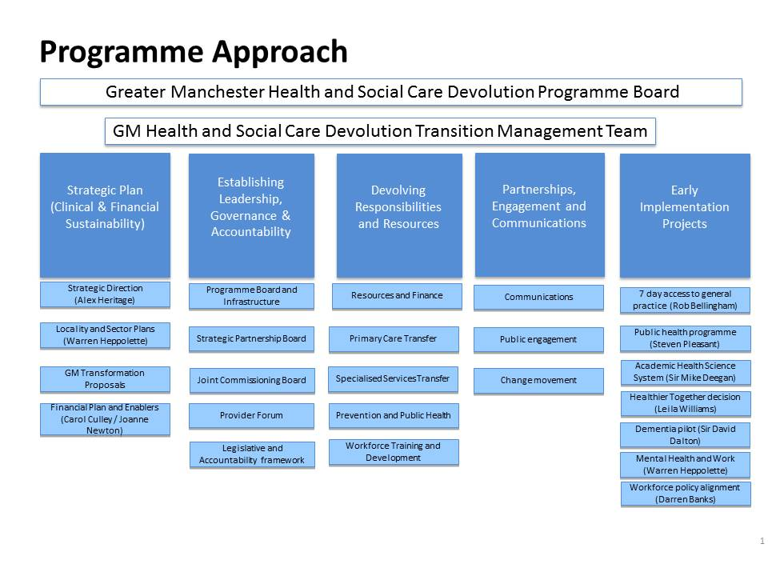
  - Key work areas 2015-2016

Greater Manchester wants to use the build-up year before full devolution in 2016 to test new ways of tackling, at a large scale, some of the major challenges faced in the region.

In early 2015 people from across the NHS and public sector in GM identified a ‘long list’ of areas they felt were both important and had the potential to make a difference quickly. All were then scored, based on potential impact, how practical they would be to implement, value for money and whether they cover different areas as well as health, for example: wealth creation, employment and social care.

A short list of seven ‘early implementation priorities’ was then drawn up. These are not meant to reflect the full breadth of change possible, but rather to give us the chance to test new ways of working together while still having significant positive impact on health and wellbeing across GM.

They are as follows:
Seven day access to Primary Care – lead Rob Bellingham, Director of Commissioning for the Greater Manchester Area Team of NHS England and for Greater Manchester Health and Social Care Devolution
Key messages: Widening access to primary care is important to people and more than a third of GM’s 2.8m people already have increased access thanks to different projects which have run in Bury, Rochdale, Wigan and Manchester as part of the Demonstrator and Prime Minister’s Challenge Fund. This is a deliberately ambitious extension of that work which is part of our wider vision to transform primary care.

Public Health programme – lead Steve Pleasant, Chief Executive/ Lead Chief for Health, Tameside MBC / AGMA
Key messages: The greatest and fastest possible health improvement will not just come from integration but also from prevention. This project will develop a programme based around increasing participation in physical activity and sport and bringing in partners from GM and national bodies.

Academic Health Science System (AHSS) – lead Sir Michael Deegan, Chief Executive, Central Manchester University Hospitals NHS Foundation Trust
Key messages: Establishment of an over-arching Board to facilitate alignment of the work of Manchester Academic Health Science Centre (MAHSC), Greater Manchester Academic Health Science Network (GMAHSN) and Local Clinical Research Network (LCRN). By aligning these bodies into an integrated system, GM’s academic health science system will lead the country.
The AHSS will also address the imbalance in investment and research between the golden triangle (Oxford, Cambridge, London) and the rest of the country.

Healthier Together decision – lead Ian Williamson, Interim Chief Officer, GM Health and Social Care Devolution
Key messages: All Greater Manchester CCGs will reach a decision by July 2015 on the recommended configuration of the Healthier Together single service model across urgent and emergency care, acute medicine and general surgery. The decisions will focus on number of single services across partner hospitals and the role played by each hospital.

Dementia Pilot – lead Sir David Dalton, Chief Executive, Salford Royal NHS Foundation Trust
Key messages: Salford will pilot a way of working which will help people living with dementia get better care, through integrating services and using opportunities to use technology and digital advances to help patients live at home safely.

Mental Health and Work – lead Warren Heppolette, Strategic Director Health and Social Care Reform
Key messages: Mental health and wellbeing plays a vital part in helping people find employment – and stay in work. Likewise being in work has a significant positive impact on mental health. This pilot, supporting a cohort of 3-5,000 people, will help develop a service model which supports unemployed people who are finding it difficult to get in to work because of mental health issues.

Workforce policy alignment – lead Darren Banks, Director of Strategy, Central Manchester University Hospitals, NHS Foundation Trust
Key messages: The majority of healthcare spend is on staff, with costs of recruitment and training significant. This piece of work will seek three areas of agreement across provider organisations in GM: common standards on pre-employment checks, statutory and mandatory training and common rates for specific targeted locum and agency staff. It will also examine areas where providers are struggling to recruit, and address issues. The benefits will include: retaining trained staff within GM; reducing the time to fill vacancies and reducing costs for locum and agency staff.

3.3 Devolution Transition Management Team
The team responsible for the early stages of devolution currently includes colleagues on attachment or secondment from a range of organisations in Greater Manchester as well as those providing their time from within their current roles. The Team are:
Ian Williamson, Interim Chief Officer, GM Health and Social Care Devolution
Sir Howard Bernstein, Chief Executive, Head of Paid Service, MCC, GMCA
Steve Pleasant, Chief Executive, Tameside MBC
Rob Bellingham, Director of Commissioning, Greater Manchester Area, NHS England and for Greater Manchester Health and Social Care Devolution
Su Long, Chief Officer, Bolton CCG
Alex Heritage, Assistant Chief Officer and Deputy Director of Service Transformation, Service Transformation for NHS Commissioners in GM
Leila Williams, Programme Delivery and Director of Service Transformation, Service Transformation for NHS Commissioners in GM
Warren Heppolette, Director of Health and Social Care, Greater Manchester
Darren Banks, Director of Strategic Development, Central Manchester University Hospitals, NHS Foundation Trust
Sarah Senior, Chief Financial Officer (currently director of Finance, Cumbria Partnership NHS Foundation Trust, coming into new post on 1 June 2015)
Carol Culley, Deputy City Treasurer, Manchester City Council
Liz Treacy, City Solicitor, MCC, GMCA
Will Blandamer, Programme Director of Care and Health Integration, Wigan Council
Katy Calvin-Thomas, Director of Planning, Performance and Information, Pennine Care NHS Foundation Trust
Andrew Lightfoot, Strategic Director, Public Service Reform, GMCA
Claire Norman, Head of Communications, Engagement and Marketing, North West Commissioning Support Unit

For more information contact gm.devo@nhs.net

