Integrated Working in the Delivery of the Healthy Child Programme: Bradford’s Integrated Care Pathway (ICP).

Bradford District Care Trust

Rugare Musekiwa
Rugare.musekiwa@bdct.nhs.uk

Version1

Case Study Overview

In 2012, key partners providing services to Children and Families in Bradford signed up to delivering services in an integrated approach. The objective of Early Years, Midwifery and Health Visiting was to deliver an easily accessible service for clients whilst formalising joint working and standardising service delivery across the district.

The Integrated Care Pathway with the support of the Voluntary sector has encouraged services that have traditionally worked in their professional silos to come together and focus on a delivery model that maximises benefits for Children and Families in Bradford. The visual pathway also makes it easier for all practitioners to know what interventions we are all offering for families.

A lot of our services are now being delivered from community hubs which in most cases are Children Centres. Services are now more easily accessible to families. The ICP interventions are based on the recommendations of the Healthy Child Programme and the Children Centres’ Core Purpose expectation. The ICP encourages the delivery of a universal service in the community and strengthening the capacity of that community by encouraging forging of links and networks. It is also about early Intervention to maximise outcomes for families and children.

Benefits and Achievements

Benefits of the ICP;

- Seamless service for families which is easier to access,
- Best use of resources through reduction of duplication of work by agencies,
- Skilled up workforce that can deliver a fit for purpose service,
- Staff motivation and job satisfaction improvement.

A series of engagement events were undertaken with both service users and practitioners to get their expectation of services they wanted to either access or deliver. These were in the form of road shows, meetings and questionnaires. All the responses were collated and a scoping exercise was then undertaken to plan how these expectations would be managed whilst still adhering to the needs of the service.

An ICP implementation steering group was formed with membership including all the Strategic leads from the organisations to ensure buying in from the top whilst grassroots staff were involved in the engagement events to ensure that everyone had ownership of the project and their voices were heard. We now have regular meetings across the district in geographical areas were representatives from organisations working with families and children sit on the same table to plan the delivery of the ICP which is a major achievement for us.

Challenges

- Data sharing due to Information Governance constraints,
- Adapting to the new ways of working,
- All services having different geographical boundaries and IT systems,
- Funding for training programmes.

We are now working in a geographical area based model were practitioners meet on a regular basis to plan how best to progress ICP delivery to meet the needs of their specific area. A Data sub group has also been set up to determine how information can be safely shared within systems and constraints of Information Governance.

Commitment to improving services has made it easier for practitioners to adapt to new ways of working. Practitioners on the ground know their area best and there should not be a one size fit all delivery model. For future projects, rolling out changes area by area might be a better option than doing a district wide roll out all at once.

Learning, sharing and sustainability

We have learnt that if people have a common goal, it is possible to achieve that and also massively influence service delivery. We also appreciate that each service area has a massive role to play in supporting clients in a different way to others whether it is the voluntary or statutory sector. By working together in a systematic way we are positively influencing the lives of Children and families in our district. We do have regular meetings in geographical areas but plan to have regular updates in various formats locally to update practitioners were we are at.

2 colleagues and myself have presented in our region at the North of England Learn and share event where we shared our model and exchanged ideas with others across the region. A colleague and I are doing another presentation at the CPHVA 2014 conference. This will be an opportunity to share our experiences with other colleagues across the country. This delivery model has been embedded in practice and will be the norm for service delivery. This will not therefore be viewed in isolation as an extra component of service specification but will be part of our day to day practice.

Additional Information

Universal Integrated Care Pathway.

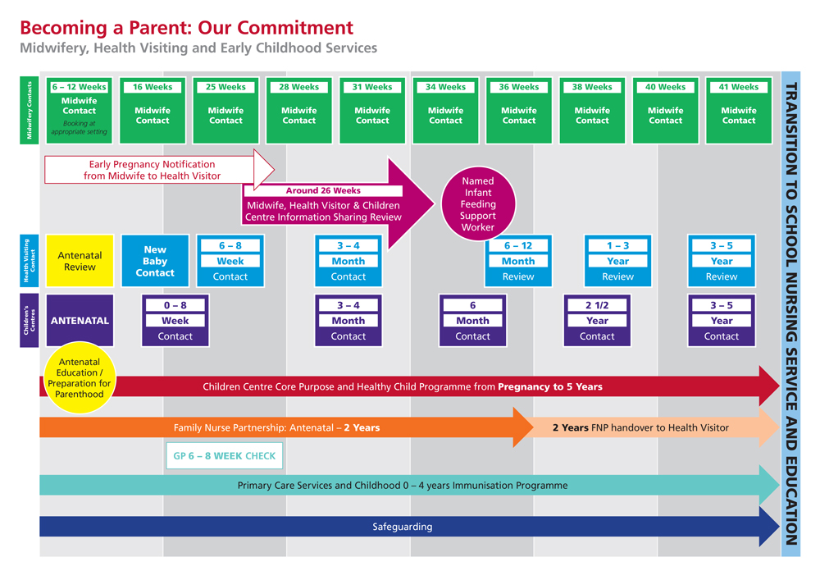

References

Munro Report (2011) Munro Report of Child Protection : A Child centred system
Public Health Outcomes Framework Department of Health 2013-2016 (2012)
The Guide to Early Years Profiles’ published by Public Health England March 2014
A Call to Action for Health Visiting Services 2011-15 Department of Health 2014
Marmott Review (2010) Fair Society- Healthy Lives

