Integrated working in the delivery of the Healthy Child Programme – Bradford’s response

Better Start Bradford

Jo Howes
Child Health Specialist – Better Start Bradford

jo@bradfordtrident.co.uk

Benefits and achievements
Better Start Bradford is a BIG lottery funded programme to work with expectant parents and families with children under 3yrs in a small part of Bradford. The lottery have chosen five sites to benefit from the funding and Bradford will receive £49 million over ten years to improve the outcomes of the children in this area. This influential investment in Bradford has given us the opportunity to change the lives of the children and families in this area. Bradford Trident leads on the programme with engagement from many partner organisations including the council, NHS, police, Born in Bradford, parents and community members. The bid process prior to the announcement of the benefitting sites included consultation with a wide range of residents, parents and children, community groups, voluntary organisations and agencies working with children and families. The partnership that has emerged from this has a very strong community lead and this is now embedded in the programme. Through Better Start Bradford we will create a programme of evidence and science based prevention and intervention to support and improve the life chances of our children.

Challenges
Better Start Bradford is just embarking on the programme and challenges so far have been within the development of the bid and consultation phase. Ensuring all projects are based on “what works” and not “what we fancy” is a challenge overcome with more understanding of the differences between evidence based, science based and innovative programmes. This is an opportunity to be a catalyst for the whole of Bradford District as we evaluate what does work in our communities. Engaging staff in the programme has at times been challenging whilst facing cuts to funding in their own spheres of work and feeling pressure to deliver ever stretched services however sharing research on the importance and influence of early intervention has re-ignited a desire in many to become involved and the opportunity to develop services to influence life chances for these children.

Learning, sharing and sustainability
Better Start Bradford have learnt throughout this process to listen to the voice of the community in the changes they desire for their families and children. Empowering parents through this programme and building a community of influence of those living and working in the area as they have a key role in championing early childhood needs. Accepting the need for a change in the way we work together so we get it right for families first time by implementing shared pathways and corresponding training programmes. The lessons learnt from all 5 Better Start sites will be shared locally and nationally. Locally partner agencies are involved in the set up and delivery of all programmes learning what evaluates well and could benefit the whole population of Bradford district and using their influence on decision making bodies with regards to early intervention. The Lottery advisers and Warwick consortium will be ensuring that lessons learnt on the benefits of early intervention will be reported to central government to influence the agenda on early intervention priorities. The ten year programme includes consideration of sustainability through investment from the partnership and commitment to continuing the successes beyond the ten years.

Additional Information
Below are illustrations of the Better Start Bradford programme. The journey of the families for the 1500 births each year in the Better Start Bradford area and how this will change for them and also a representation of how the various projects within the programme will improve the three different outcomes for children over the ten years.

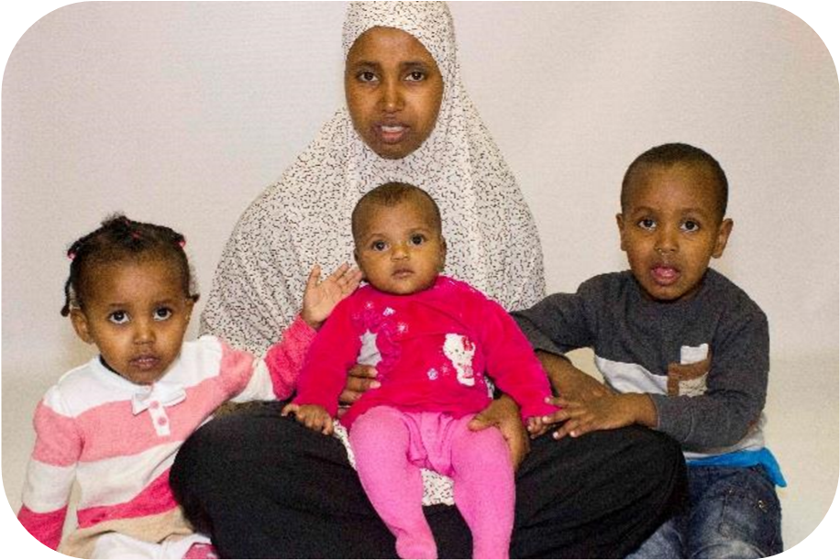
How things will

change for families

Our m
um wa
s well prepared
for our

birth thanks to the
antenatal programme and
help from her Doula, wh
ich
made her more relaxed
when we were

first born

Our
mum had help
with healthy eating
and exercise

when
she was pregnant,
and now we are
healthy and love our
food

Our

family learnt about
baby brain development
so they talk and
sing to
us, even when we were

just a bump!

Our m
um breastf
ed
us and was

sup
ported by the
Volunteer
Breastfe
eding
Sup
porters, this
helps to build our
immune system
s

Our
homestart
volunteer showed
our

mum where the
nearest

Children’s
Centre is so we have
mad
e friends and she
does not feel

isolated

Our

m
um received a
Bookstart B
ump Pack
from her Midwife, and
we will receive books
up until our

3
rd

Birthday

We have fun with our

d
ad
at Bookstart corner
learning new rhymes and
songs, this helps
us to
develop our language

The places
we
walk
and play
have

less
air pollution

which
means our

brain
s

will develop better

Our family know what
to do if we

cry
through the Coping
with Crying DVD,

so
they are less anxious
when we

do

O
ur life c
hances will

be

improved because….

Our mum and dad are
really confident about
how to give us the
best start

and we feel
healthy and loved

