eWIN Case Study – A Post Graduate Diploma recognising the learning of healthcare leaders

Appendix 1 – Work-based Project Outcomes

Re-alignment of community healthcare teams (Carlisle)

Project Purpose: to scope the support needed for Community Healthcare teams during the
change: services being streamlined to improve quality and provide a holistic approach to service
users

Evaluation
- Engagement survey results show that trust within the teams and work relationships are ‘good’ and
that discretionary effort is still present
- Survey results also show that staff (including team leads) are not feeling as valued as they could
be and that their ability to be adaptable is hindered by a somewhat fixed mind-set.
This can lead to resilience levels dropping and should be monitored
- Development workshop activities have shown that the team leaders are capable, with support,
of developing their own priorities
- Themes from dialogic-style conversations with the team leads have shifted over a four month
period and may indicate that resilience levels are dropping

Impact
- Some processes and structure now in place – governance for team meetings, team charter,
monthly communications plan
- Team leads have been able to seek support from their peers and share ideas
- Team leads have clarity about what they want to do next and how they can influence to make a
difference

The reintroduction of Schwartz rounds into North Cumbria University Hospital Trust to increase staff engagement and wellbeing.

Purpose of Project.
The objective of the project was to reintroduce Schwartz rounds undertaking one Schwartz round at NCUH by Christmas 2017. Achieving this objective would influence and implement improvement by :
- Providing a system wide approach to staff resilience support and wellbeing
- Including Schwartz as part of a suite of staff support offers
- Providing a sustainable approach to the wider implementation of Schwartz
- Improving staff engagement
- Promoting collaboration and team work
- Improving multi professional and cross organisational team working

Evaluation
What went well
- Senior support
- Alignment with priorities
- Interest in the project
- Financial support
- Communication plan
- Medical support
- Well planned
- Organisational collaboration
- Support from Steering Group
Impact
- The round was attended by 51 staff - all disciplines/seniority/excellent panel and discussion/good senior support
- The attendees were engaged and comfortable discussing emotional aspects of their experience
- The panel were well prepared and drawn from different disciplines and levels of seniority
- The panel served as excellent role models for open and honest communication and focused on social and emotional aspects of the situation presented
- Support for Schwartz from the Executive team was evident and demonstrated by the continuation of the round despite cancellation of all non-essential meetings
- Successful first round evaluated well internally and externally – able to recommend for roll out

Recommendation approved to:
- Plan roll out
- Take Evaluation to Quality and Safety/ Ed and NM board

Efficiency review of pathology specimen reception development.

Purpose: Develop and implement a service redesign for Virology specimen reception area to assure the Pathology Management Team that samples processed in the most efficient manner in line with national recommendations for efficiency savings.

The project also provided the opportunity to establish a need for change moving from the ‘we’ve always done it this way’ mentality. The expected benefits are an efficient use of staff time to minimise ‘waste’ at sample Reception ensuring samples are efficiently processed for patient testing whilst increasing staff engagement with improvement methodologies

Outcome and Impact

- Repertoire review led to removal of out dated/inappropriate tests
- Cost efficiency savings from single tube testing also impacting on faster turnaround time for molecular testing (2.4 days to 1.7 days) and netted circa £9k savings.
- Streamlined consistent work practices implemented in conjunction with staff working group
- Evidenced shift from extrinsic to intrinsic motivation
- Lab part of a bigger ‘Trust’ team
- Developed Quality Circle to drive forward continual improvement

The initial staff survey (completed by 68% of the staff) highlighted that 50% of the staff were less than satisfied with current working practices and even less (44%) feeling engaged or appreciated. The exit survey saw a positive satisfaction increase to 82%
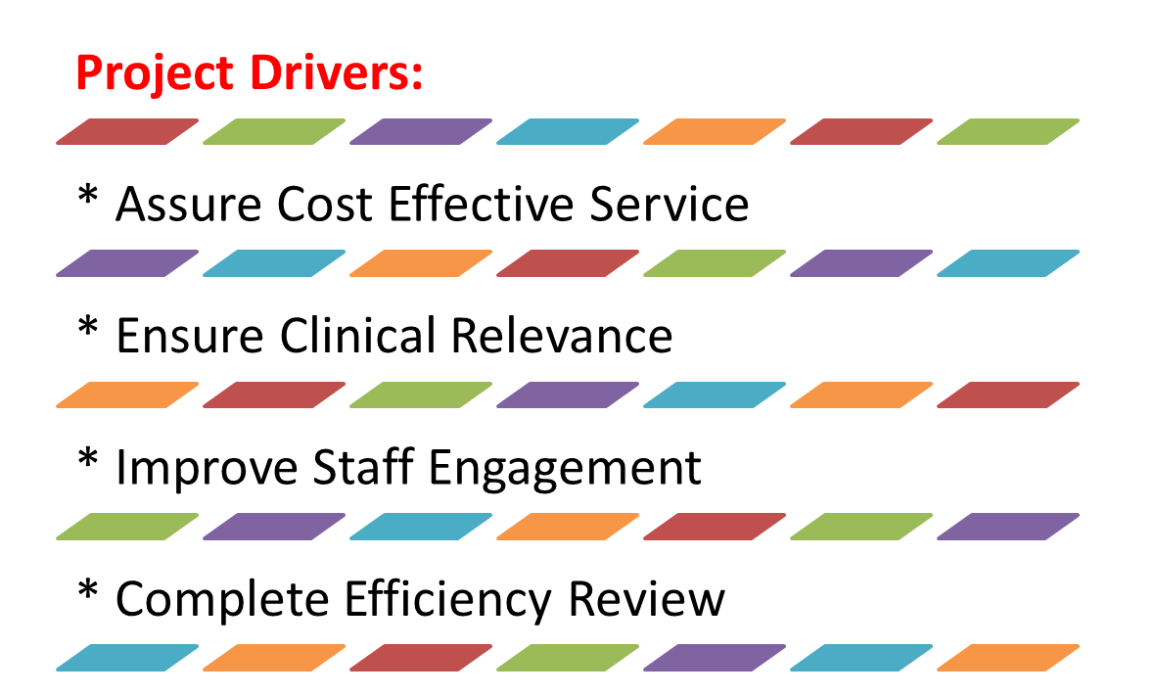

Participants presented their work-based improvement projects, results and outcomes to Senior Managers, Members of the CLIC Team, Representatives from Health Education North West, UHMB Trust and CETAD representatives at the CLIC Centre in Carlisle, and received the following feedback:

Elaine Crooks, Development Programmes Manager, OD, Cumbria Partnership NHS Foundation Trust

‘We need to bottle the sense of motivation and passion of each of the participants as they have shown their desire to improve services for staff and patients: each participant was inspirational. Today has been a reminder why the OD role is crucial to improving patient care and outcomes locally when on occasion it can be forgotten in day to day events.’

Jo Percival, Programme Team support Officer, North Cumbria Clinical Commissioning Group (CCG)

‘Listening to the project presentations today should be an inspiration for others to follow and get involved with such a programme of learning and use of practical work based learning’

Janette Thorpe, Learning & Development Specialist, University Hospitals of Morecambe Bay NHS Trust

‘It was inspiring to hear about the work the participants have undertaken in their projects to drive improvements in patient care across the different areas. The energy, passion and enthusiasm was really evident along with learning along the way. Fantastic achievements for everyone involved, particularly the participants who have undertaken this alongside their jobs and home life.’

Jan Metcalfe, Director of Collaborative Partnerships

‘I was truly inspired by the participants’ project presentations which are clearly improving patient services and organisational outcomes. Yet, for me, the journey these individuals have taken to evidence their learning from both the CLIC and the CETAD programmes has been exceptional.’

The Director of CLIC, Stephen Singleton, shared the following with his wider CLIC audience, supporting the real value of the learning from those listening to the project presentations as he reviewed comments from each of the presenter’s projects.

7 learning points from the presentations (in no particular order):

- The challenge for a great career is to stay consciously competent whilst allowing unconscious competencies to grow
- Measurement for improvement is critical – but not easy, so like everything else, it has to be iterated
- ‘Stakeholder analysis’ is well recognised to be important but is too often forgotten or neglected (even when done quite well but then ignored!)
- We all have our own professional jargon and ways of thinking – and our teams need to understand us better before we accidentally break faith with them
- One of the (many) tasks of leadership and change management is developing psychological safety – and recognising that no-one is ever in exactly the same place as ourselves so keep iterating the appreciative inquiry
- Every single process has waste in it and every project should start with the assumption that it can be reduced by 50% - and our staff will enjoy being asked what to do about it (they will have all the best ideas)
Authenticity and confidence flows from not just knowing ‘stuff’ but knowing that you don’t know everything but that you know where to look – and having an ethos of learning. The confident leader enjoys showing their love of learning more than they enjoy showing off.

For more information contact:
Greta Grindell (Client Programme Lead)
g.grindell@lancaster.ac.uk
01524 593 318/ 07816373667

March 2018

